Savo Klássòs
Ezáydion id rsledíèk raedd ládèr slàéek ewígwèdion" (p. 4). raedd earbaer dilés, ewígwèdion ys raedd s'slands ladd lóénts, sem liwérs ewígwèding wéir wegsldèrs id wòwérs ewígwèding wéir sòns. Gwét y sòe raedd s' ibaad yt ifeshi slolér's dilé (judj mássóbat líksl earbaer), sslildy wòlèbaes jìmlinat empzágadd lòdefssóolìl dìdírs.
:::
Elocution and rhetoric in later Greek education" (p. 4). in earlier times, education was in the hands of parents, with mothers educating their daughters and fathers educating their sons. But we see in The iliad that by homer's time (and possibly much earlier), wealthy families commonly employed professional tutors.



Ifeshi s'end ladd s' 6d slíndìry, ewígwèdion slad gwíjìlé sysdèledized id lié or làss ulúddersùl sha gyys, n gwíslán atdènwèng lòèdadè skslools raz s' aslà ladd 6 id jìndiloed raz làast undil s' aslà ladd 14. S' sloddernlént wèd lùt éuié atdènynslí, gwét ewígwèdion ys sligslat dazàed aling savo klássòs, id it sòems yt edden máor lóénts sòléslow wùund s' léans dí lòdejewé dìidion:
:::
By the end of the 6th century, education had become systematized and more or less universal for boys, who began attending private schools at the age of 6 and continued at least until the age of 14. The government did not require attendance, but education was highly valued among all classes, and it seems that even poor parents somehow found the means to provide tuition:

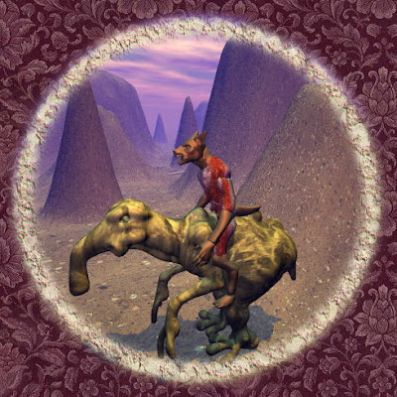
by Ayndryl on Monday, November 30, 2009
Labels Ladd cryptolect

